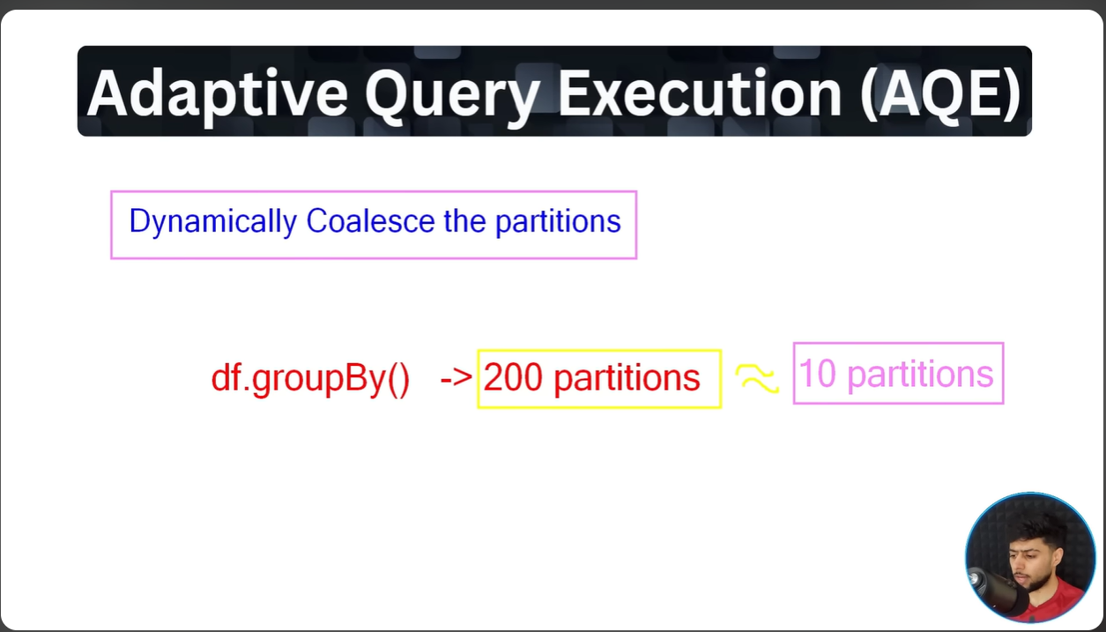
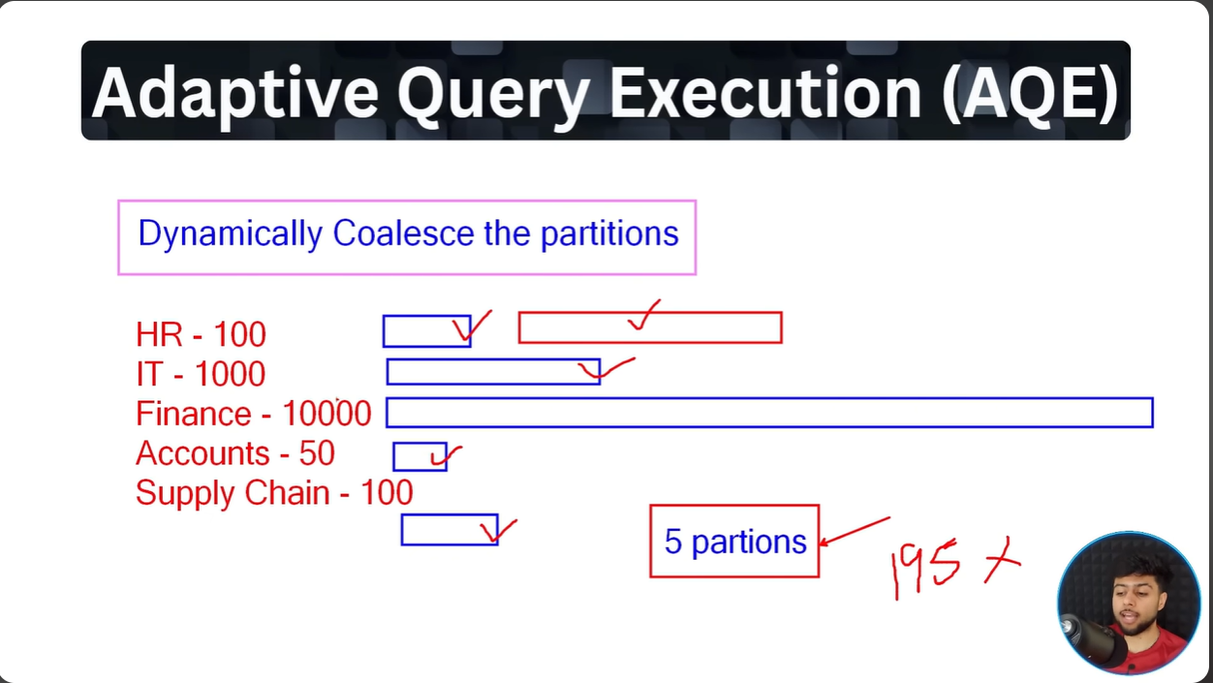
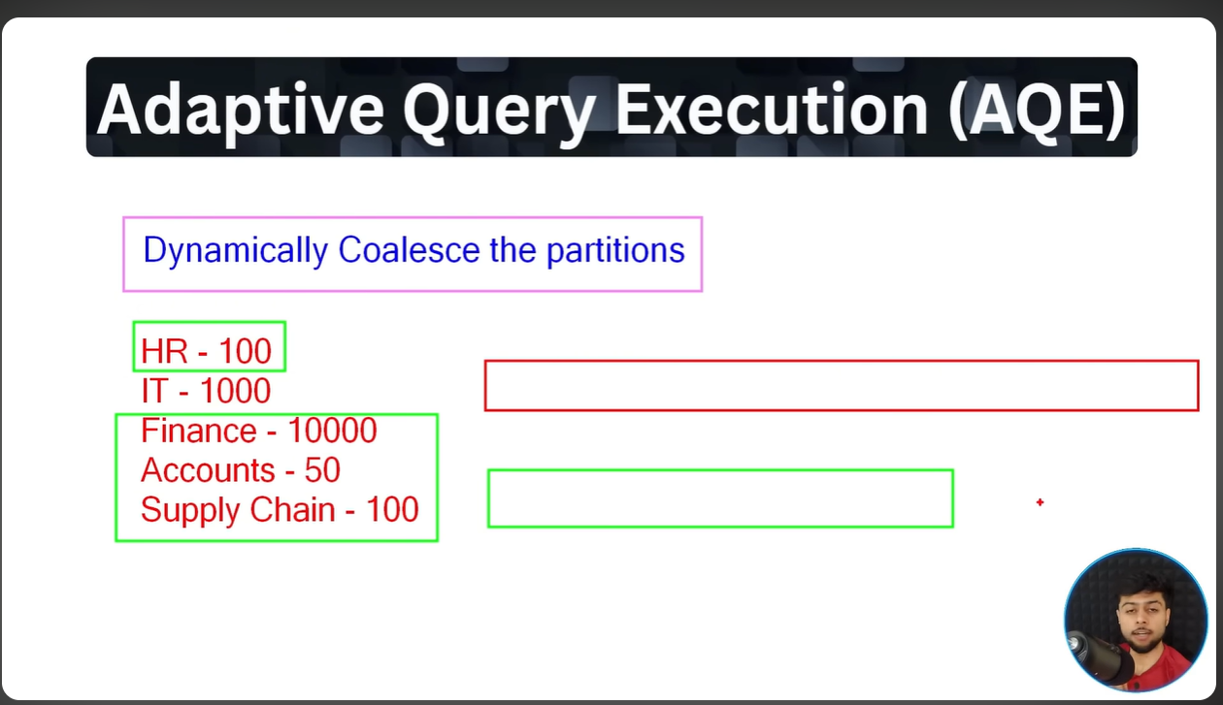
The idea is to distribute the data evenly across partitions. So it will simply merge the other small partitions.

Below is an example of without AQE :
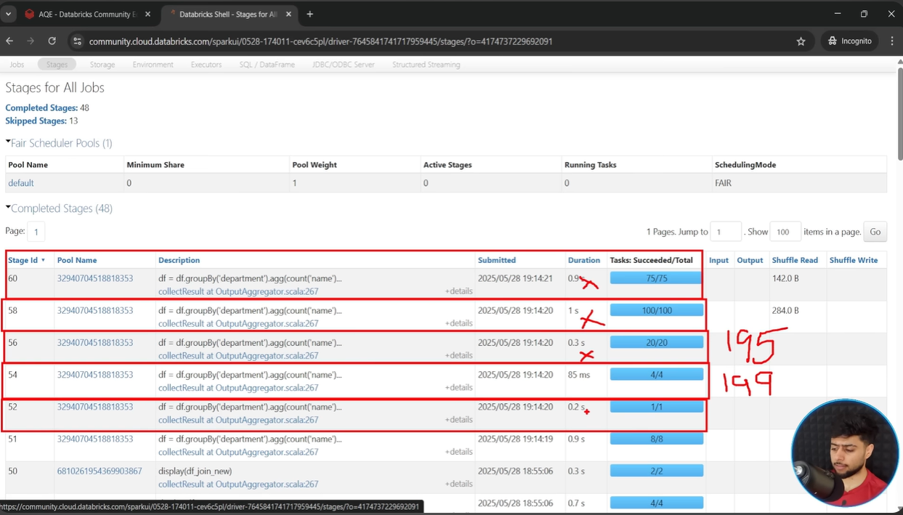

Below is an example of with AQE :
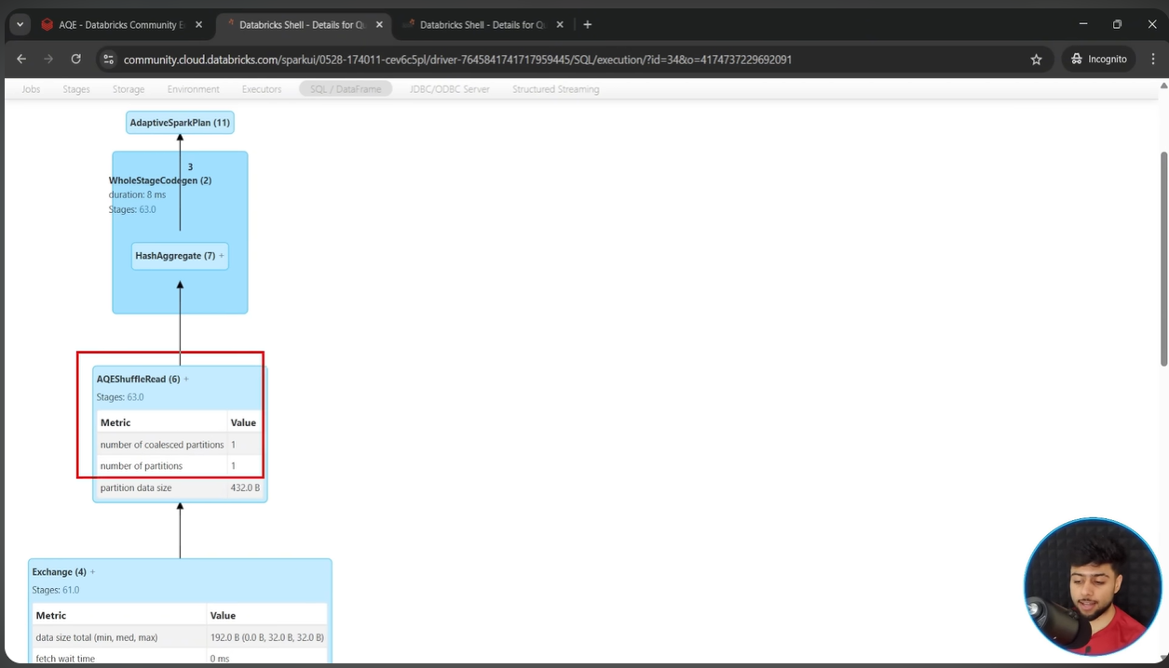

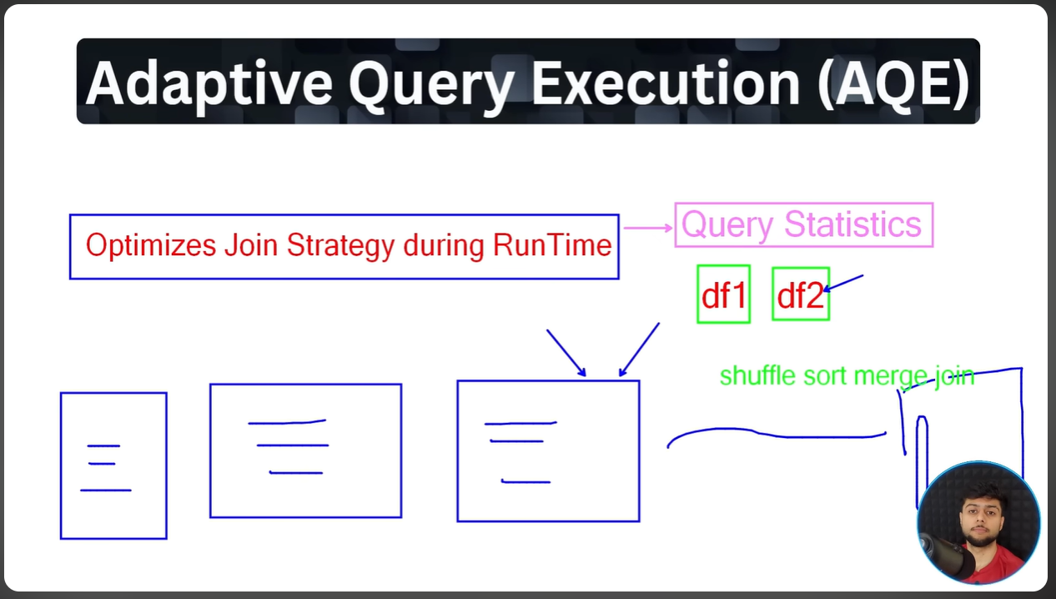
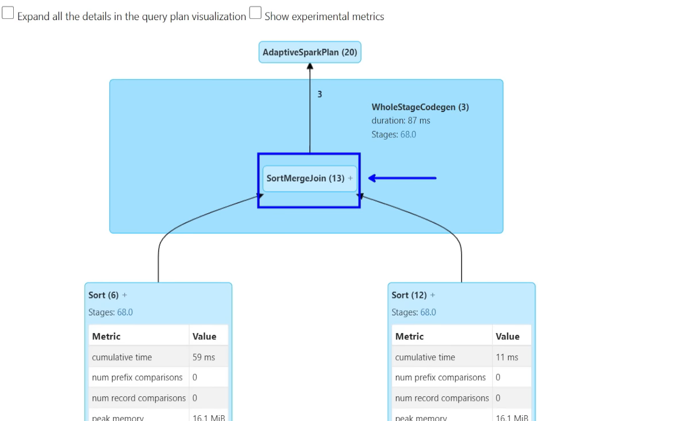
Based on query statistics, AQE changes the physical plan at the runtime and optimizes the plan to select the best plan.

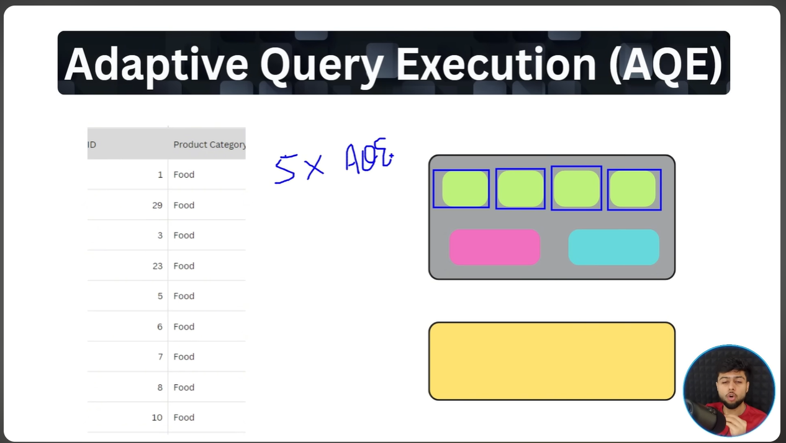
For data skewness like this , it would divide the partition into smaller partitions based on some eligibility criteria/rules

